The Arasaka Corporation is a world-wide megacorporation dealing in corporate security, banking, and manufacturing. It is one of the most influential megacorporations in the world.

The company is also the largest distributor of Japanese-made merchandise throughout the American, European, and Asian markets.

**Arasaka Corporation**

PROJECT COMPUTING REPORT

Michael Inso – ACCP

APTECH QATAR - P00188933

Statement and Confirmation of Own Work

|  |
| --- |
| ***A signed copy of this form must be submitted with every assignment.***  ***If the statement is missing your work may not be marked.*** |

Student Declaration

I confirm the following details:

|  |  |
| --- | --- |
| Candidate Name: | MICHAEL G. INSO |
| Candidate ID Number: | P00188933 |
| Qualification: | L5DC |
| Unit: | COMPUTING PROJECT REPORT |
| Centre: | APTECH QATAR |
| I have read and understood both NCC Education’s *Academic Misconduct Policy* and the *Referencing and Bibliographies* document. To the best of my knowledge my work has been accurately referenced and all sources cited correctly.  I confirm that this is my own work and that I have not colluded or plagiarised any part of it. | |
| Candidate Signature: |  |
| Date: | 9/20/2022 |

**OPS020_dec16_Candidate+Statement+of+Own+Work.doc**

**OPS020_dec16_Candidate+Statement+of+Own+Work.doc**

Acknowledgement3

Introduction of the Araska Corporation4

Report & Technical note: Transport and storage & Advertisement5

Database Entry6

Araska Corporation Website 7

Araska Corporation Website back-end and front-end9

Araska Corporation Website Security Overview19

Araska Corporation Website Treehouse 20

Araska Corporation Website Lighthouse20

References & Bibliography25

Figures:

Figure 1: Relic 6

**Acknowledgment**

This NCC-UK Computing project would not have been possible with hard work and perseverance and account of knowledge and research accumulated in the project.

I am conveying myself of appreciation and acknowledgement to my current computer education school Aptech Qatar. Offering me the astounding opportunity work on this difficult assignments/projects on the title of Arasaka Corporation unit of Computing Project Report for NCC-UK Diploma 5 Computing, which also direct me in doing a quantitative of research and analysis of the subject. I also obtained many advance comprehensions, vocabulary, and expertise in computing projects.

Furthermore, I would like to be appreciative of the professor, staff, and the faculties for their great assistance. And additionally, to be indebted to my family who gave me love, support, and accommodation. They aid me a massively in finishing this assignment/project within the narrow span of schedule. The year 2022 was a great distress to all of us because of the global covid-19 pandemic. We hope 2023 would be a pre-eminent year for all of us and all would go back to normalcy.

**Introduction**

The **Arasaka Corporation** (Japanese: **アラサカ社** or **荒坂社**), is a world-wide [megacorporation](https://cyberpunk.fandom.com/wiki/Corporations) dealing in corporate security, banking, and manufacturing. It is one of the most influential megacorporations in the [world](https://cyberpunk.fandom.com/wiki/Earth). The company is also the largest distributor of [Japanese](https://cyberpunk.fandom.com/wiki/Japan)-made merchandise throughout the American, [European](https://cyberpunk.fandom.com/wiki/European_Economic_Community), and Asian markets. Arasaka-branded weapons and military vehicles are among the most sought after by police and security firms. Over the years, it has developed a dark reputation as a corporation that is to be feared and one which covers its tracks using assassins, an army of lawyers, as well as an alleged connection to the [Yakuza](https://cyberpunk.fandom.com/wiki/Yakuza).

The Arasaka Corporation maintains the largest and most powerful armed forces of any corporation in the world, with their guards renowned worldwide and feared by many. Most firms will look to licensing from Arasaka corporate security guards, couriers, or mercenaries to protect their assets. However, Arasaka assets take priority if they are at risk and the troops themselves are loyal to death to the Japanese conglomerate.

Arasaka has made a habit of buying up other companies worldwide, and bleeding out the competition of other Japanese corporations. They also give a heavy amount of support to Japanese communities all over the globe, despite their business practices and overall history being considered unethical.

**Report**

My computing project proposal is a **Arasaka Corporation** Website, I’ll be developing a dynamic website with home, landing, product, platform, support, company, and language, donation, social network links, and it’s front-end and back-end code are Java, Javascript, CSS, C, C#, & HTML etc. it would be running in also be using a woff fonts.

We will be using **.jp** domain buying it from Cloudflare since the company is from Japan founded by **Saburo Arasaka**. We will be using Cloudflare to protect against DDOS and penetration tester and illegal hackers.

The company website will be focusing in public crowd offer, venture capitalist, and angel investors. It will be developing the **Relic** is a series of [Arasaka](https://cyberpunk.fandom.com/wiki/Arasaka" \o "Arasaka) biochips allowing the storage and manifested reading of digitized human psyches known as [engrams](https://cyberpunk.fandom.com/wiki/Engram).

**Technical note: Transport and storage**

The **Relic biochip** must be stored and transported in stable thermal conditions and in an appropriate neural environment. Even momentary exposure to temperatures falling outside the recommended range could result in permanent damage to the technology. It is currently recommended to store the Relic device in Arasaka laboratory-certified isothermal containers to ensure a stable storage temperature within 2-8 degrees Celsius (35.6-46.4 degrees Fahrenheit).

## **Advertisement**

*The Relic® : Advanced consciousness-saving technology from Arasaka Corp., packed onto a shard that is the pinnacle of minimalist design. Relic® and The Relic® are registered trademarks of the Arasaka Corporation. Any similarity to products or services that are either extant or in development is purely coincidental. The compilation of personality-construct data and its operative writing to data carriers is a nascent realm of technological, neurological and psychological exploration - results may vary.*

## **Database Entry**

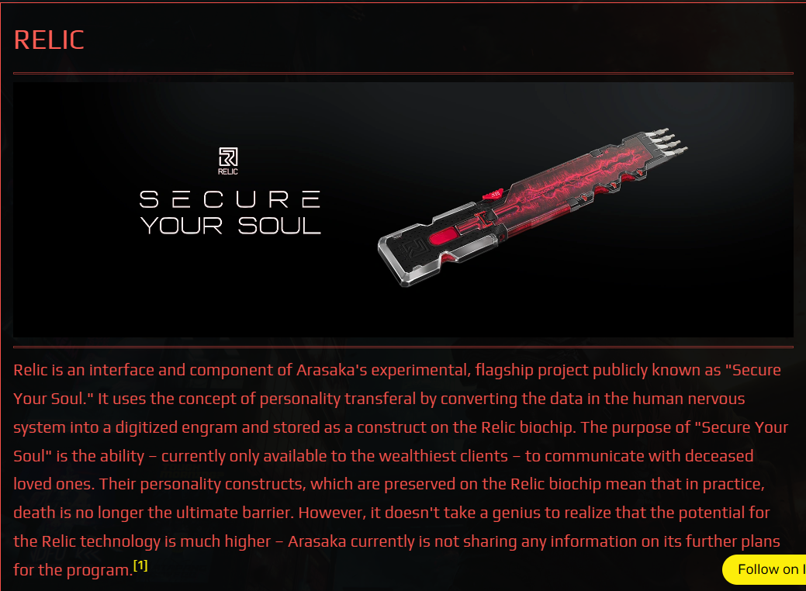

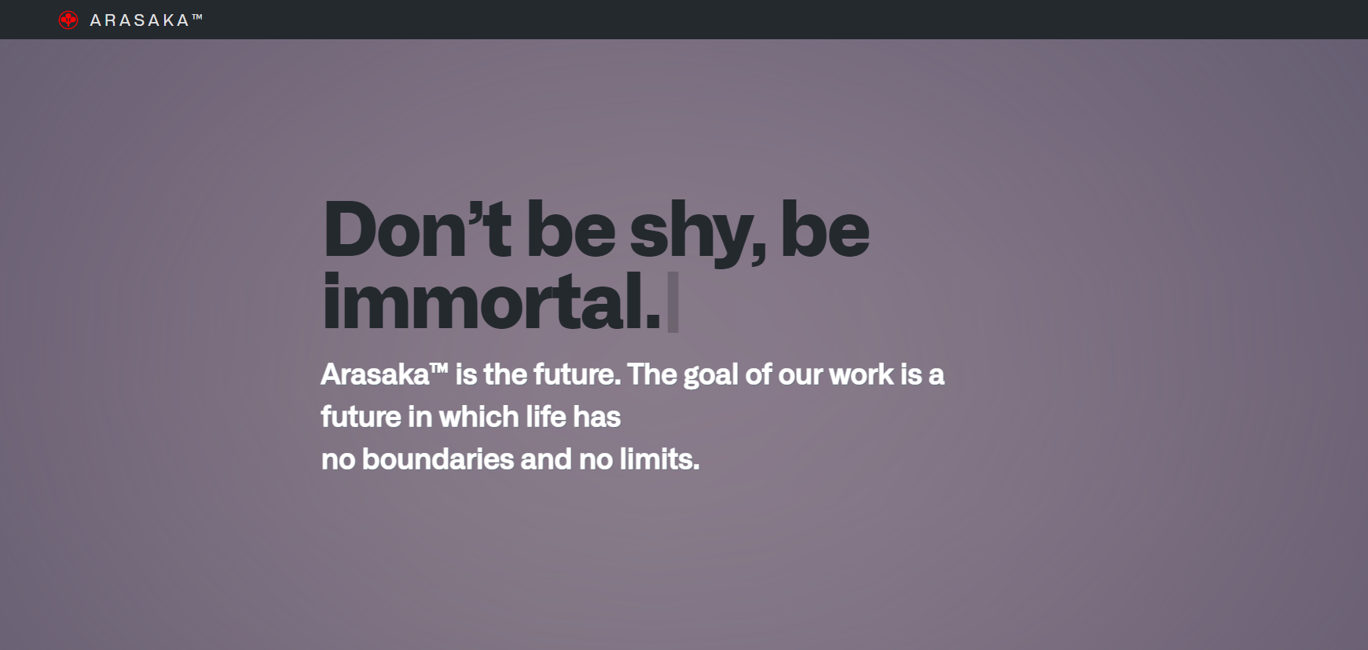

1. **Home Page and Landing Page of Arasaka Corporation Website**

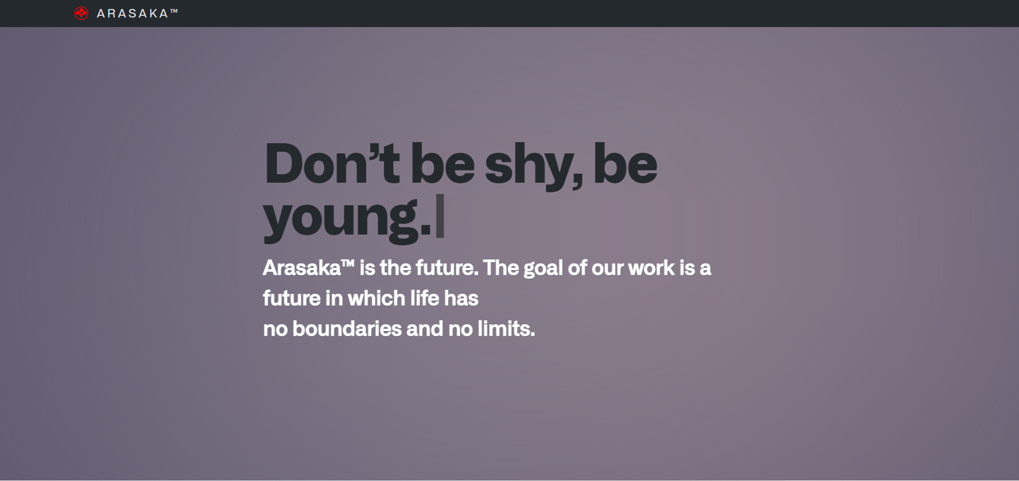

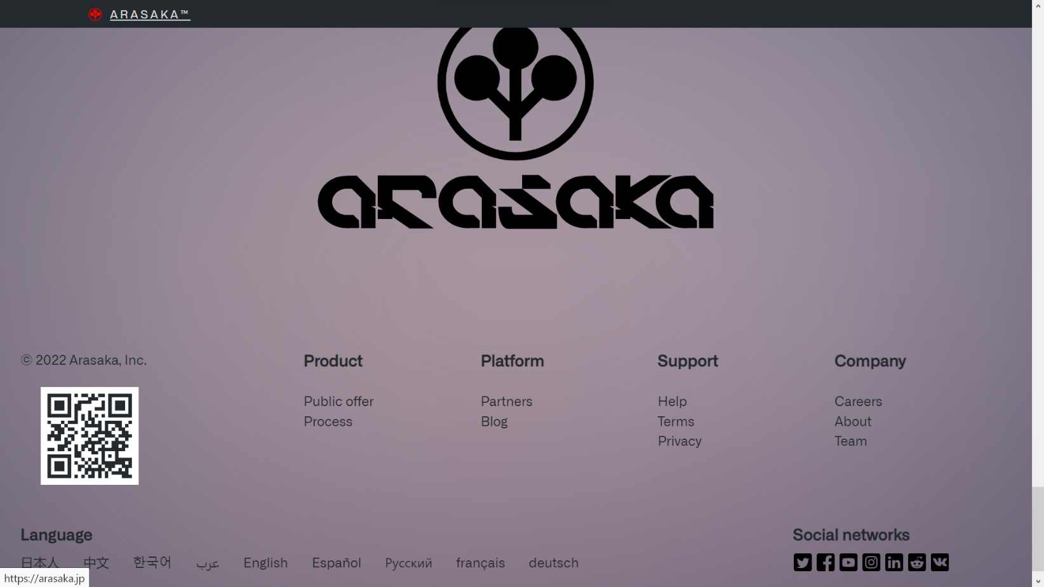



1. **Home Page and Landing Page of Arasaka Corporation Website end/last page containing Logo, Products, Platform, Support, and Company, Social networks links, Qr Code, Different Languages**



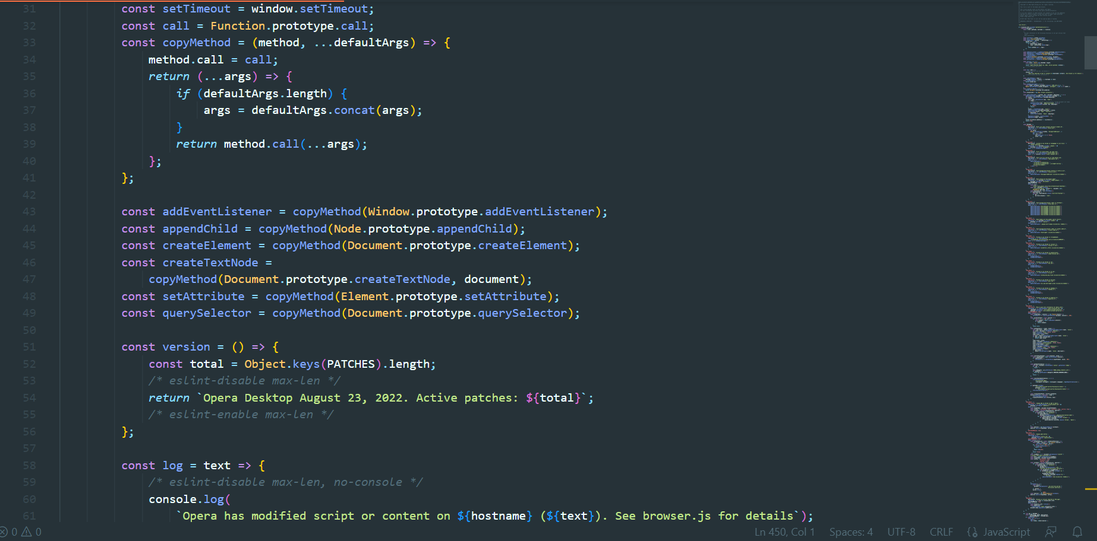



1. 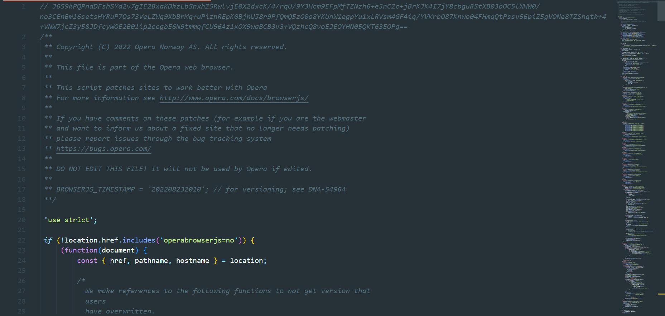**Arasaka Corporation Website Browser Javascript #(1-2)**

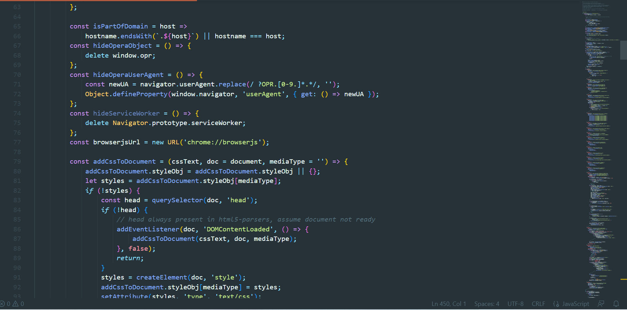

1. 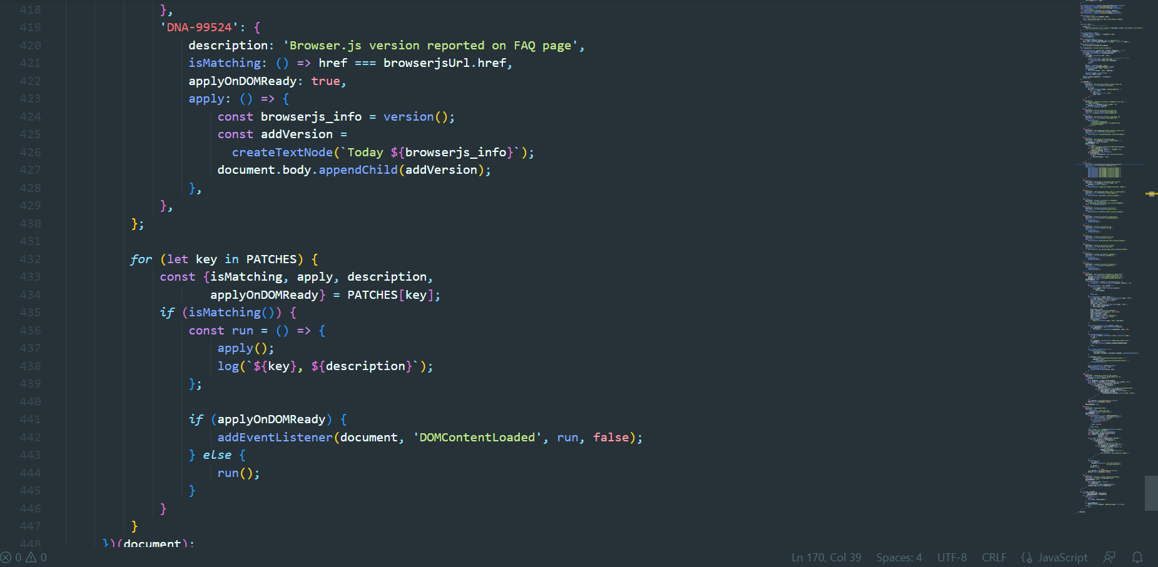**Arasaka Corporation Website Browser Javascript #(3-4)**

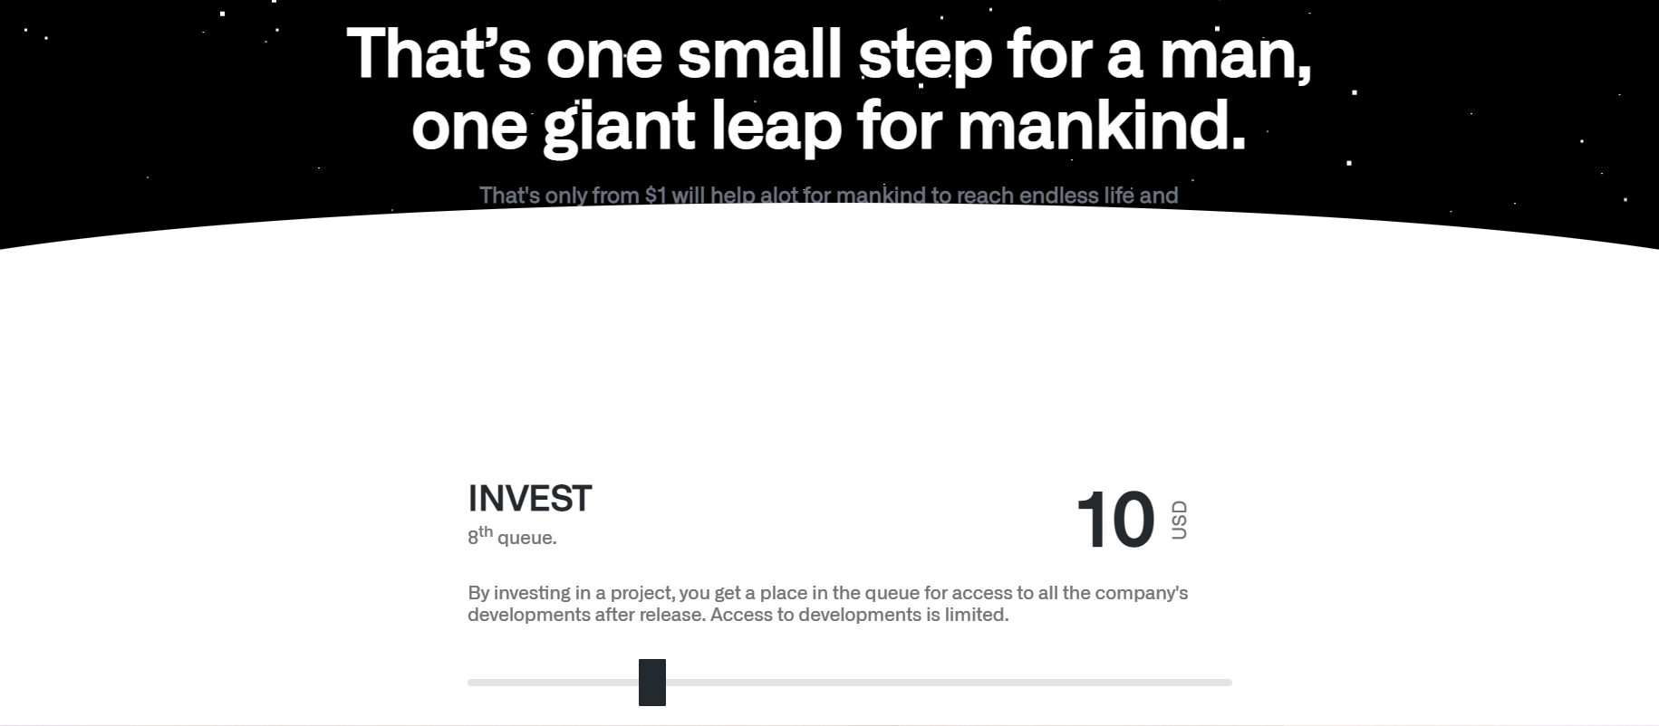

1. 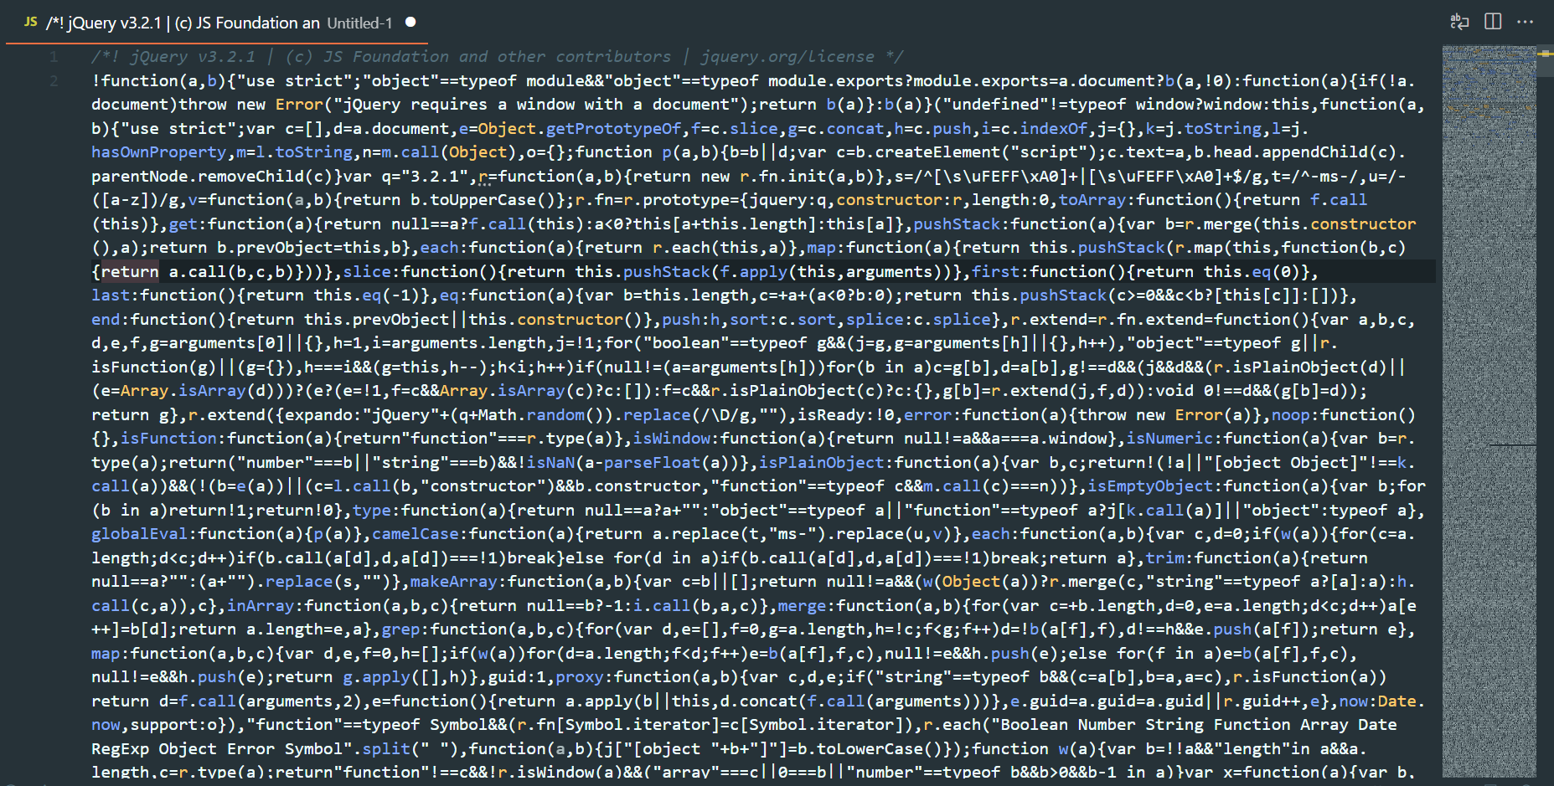**Arasaka Corporation Website Investment Page**
2. **Arasaka Corporation Website JQuery Javascript**

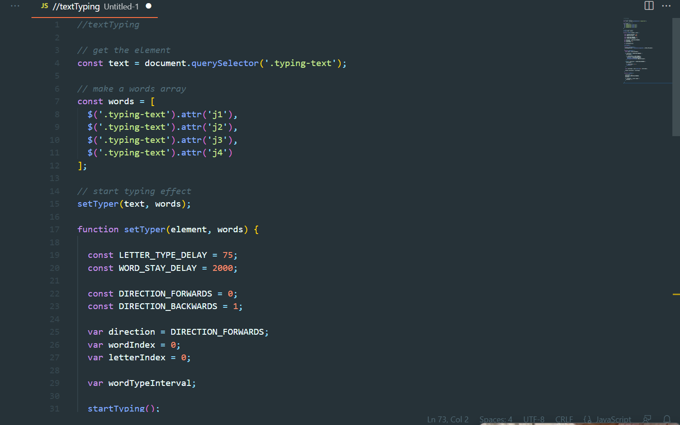

1. 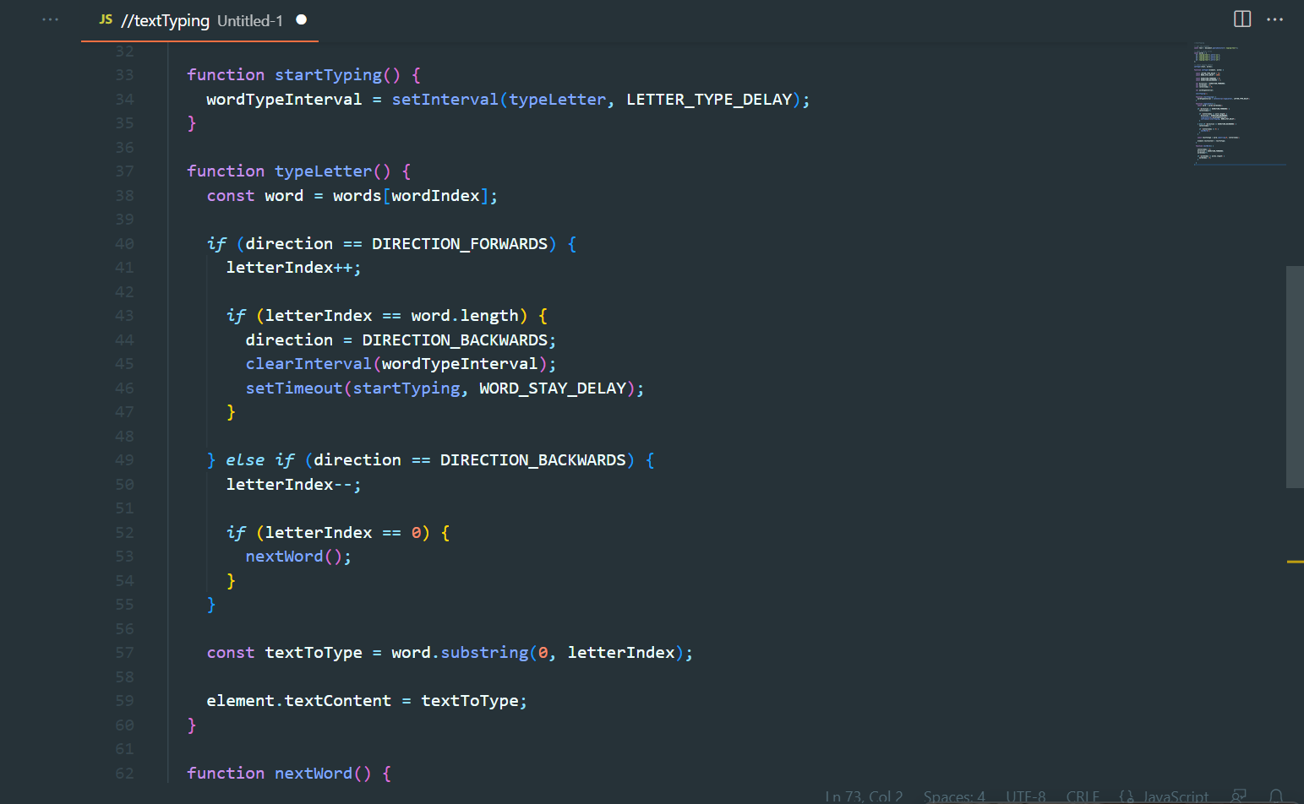 **Arasaka Corporation Website Javascript**

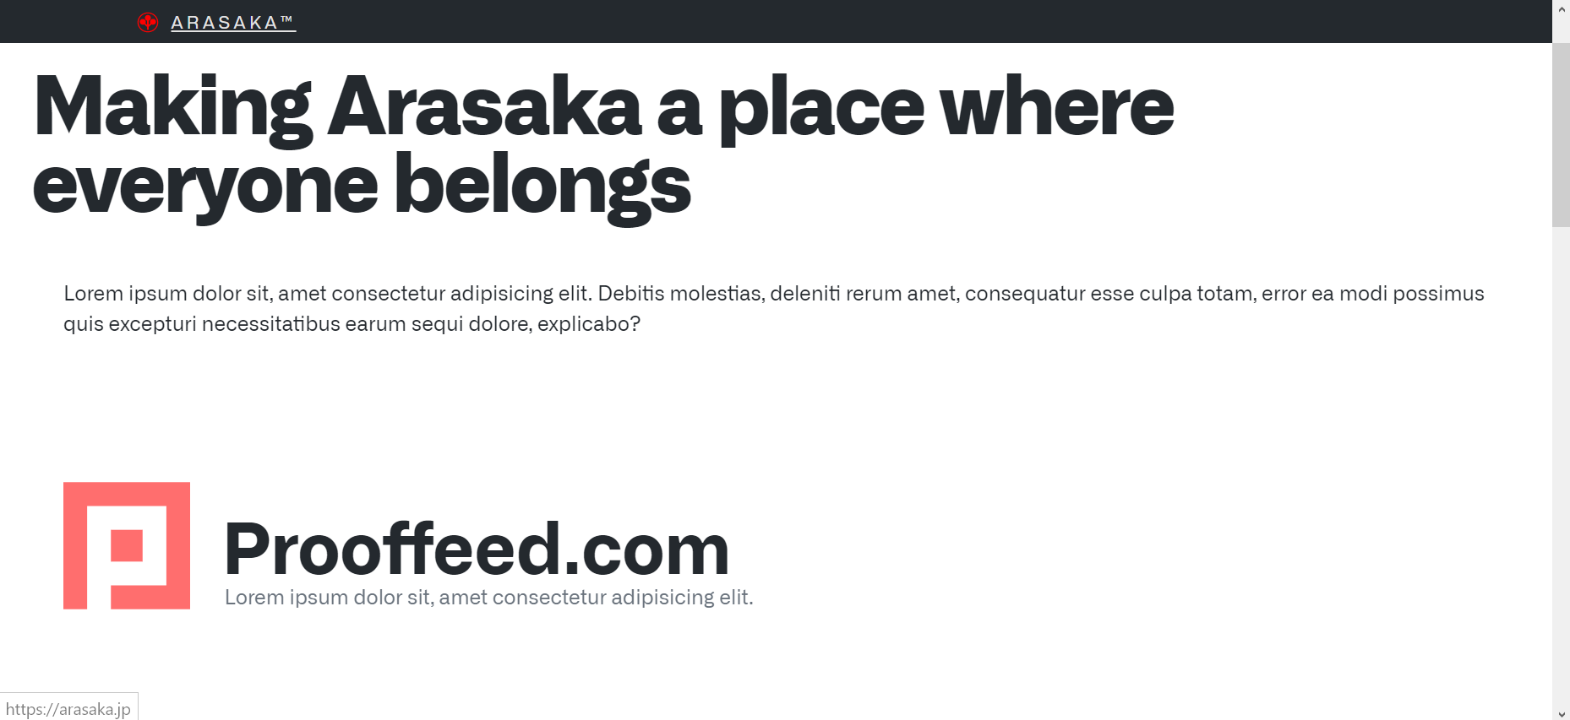



1. **Arasaka Corporation Website Platforms Partner Page in Latin and English**



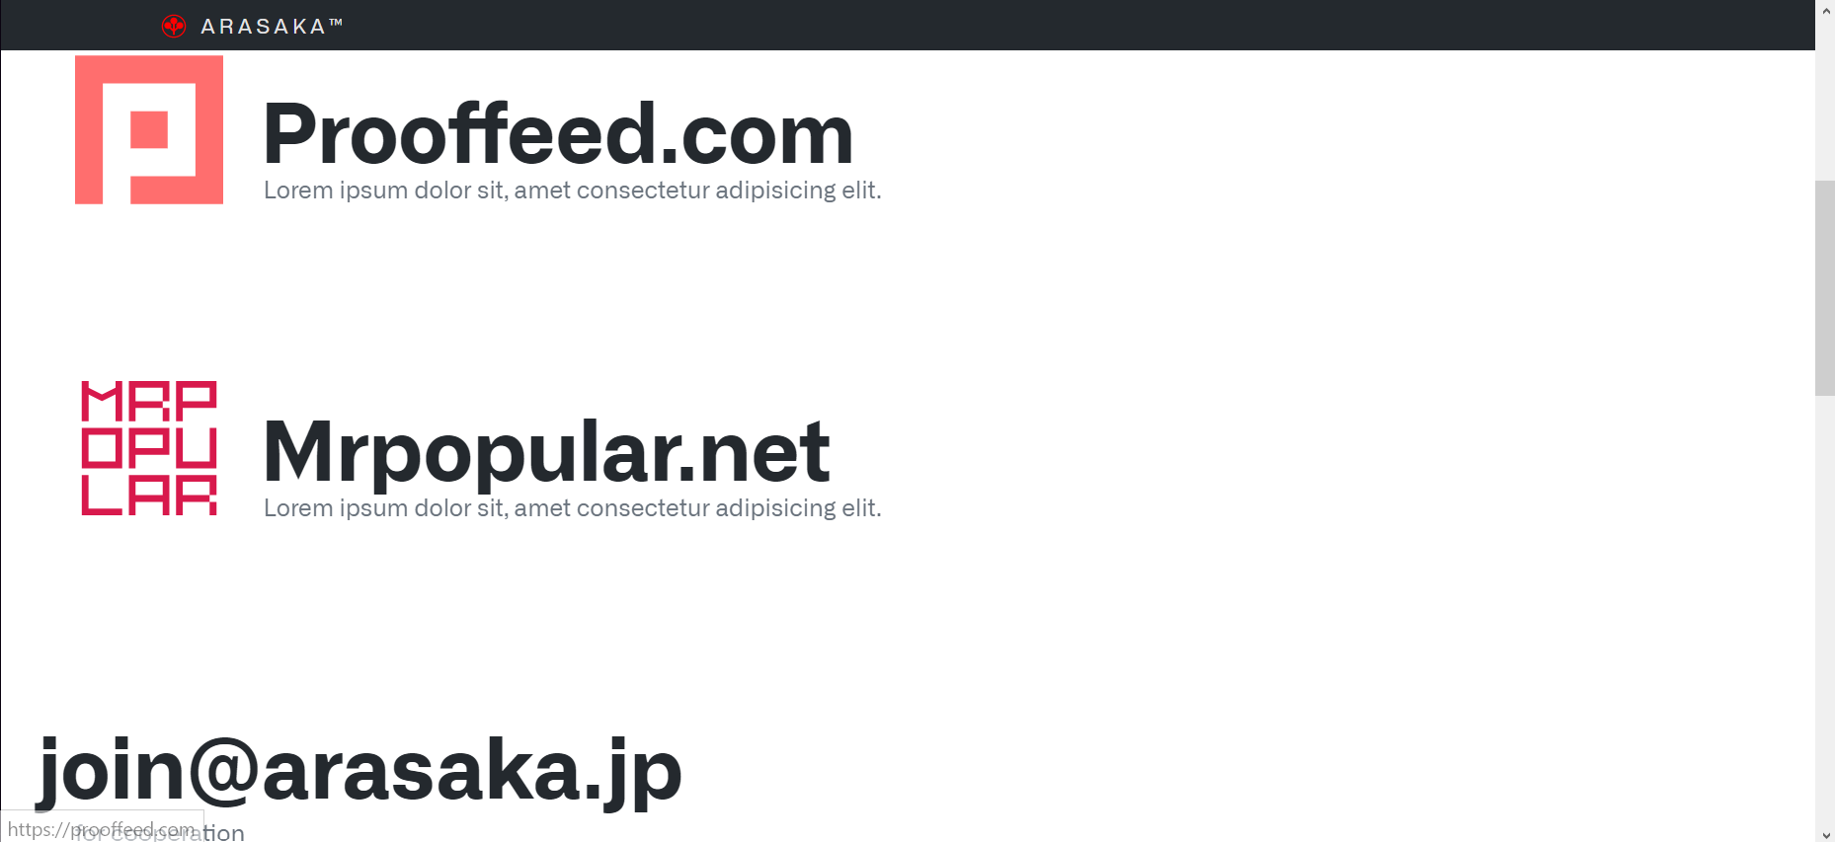



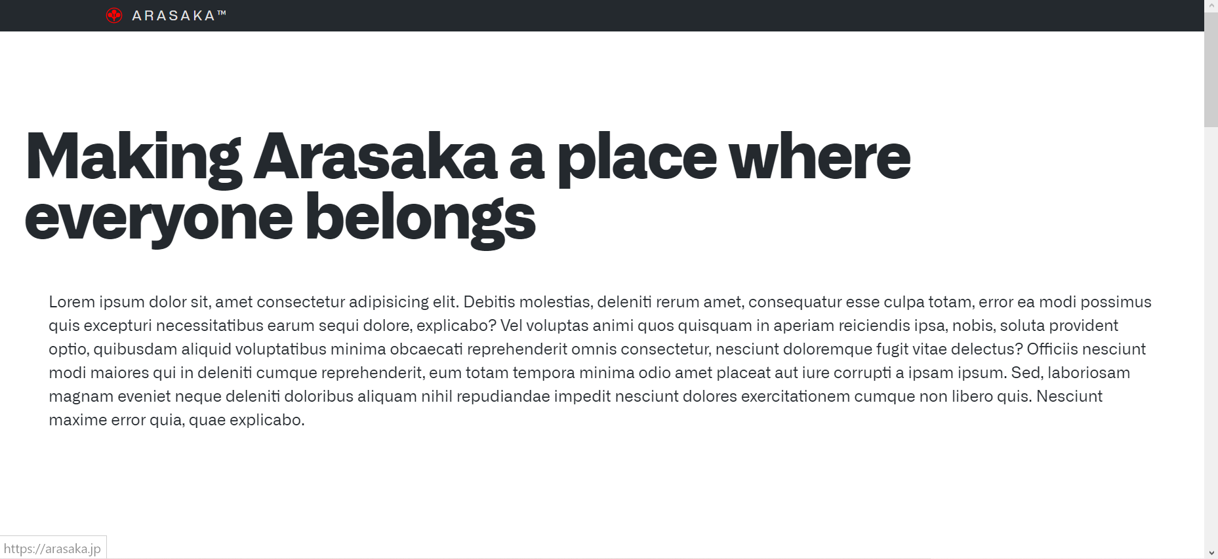



1. **Arasaka Corporation Website Products Public Offer in Latin**



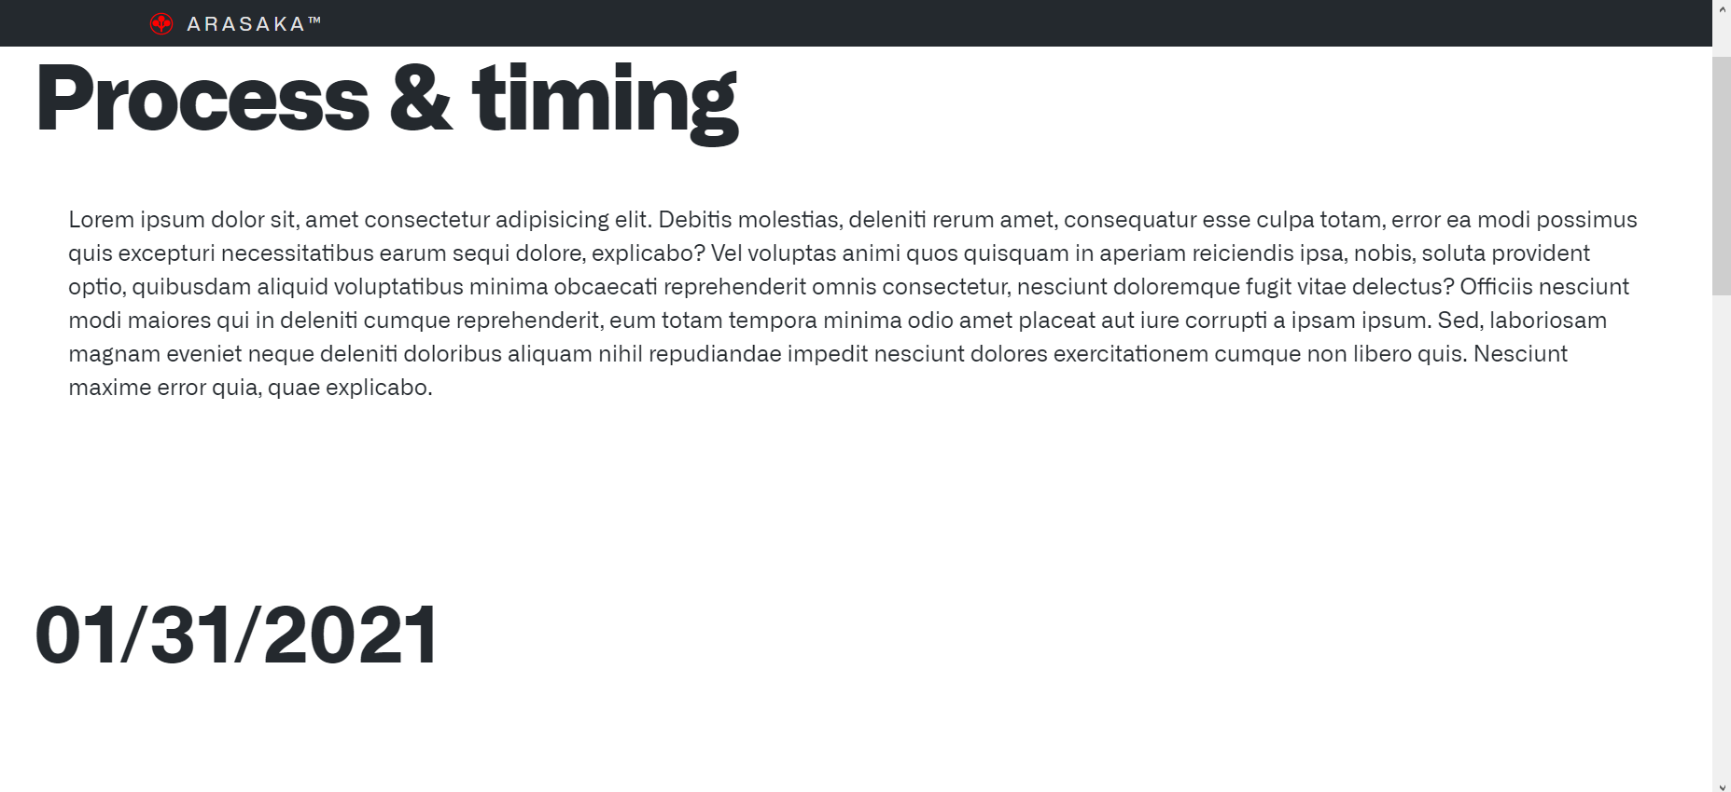

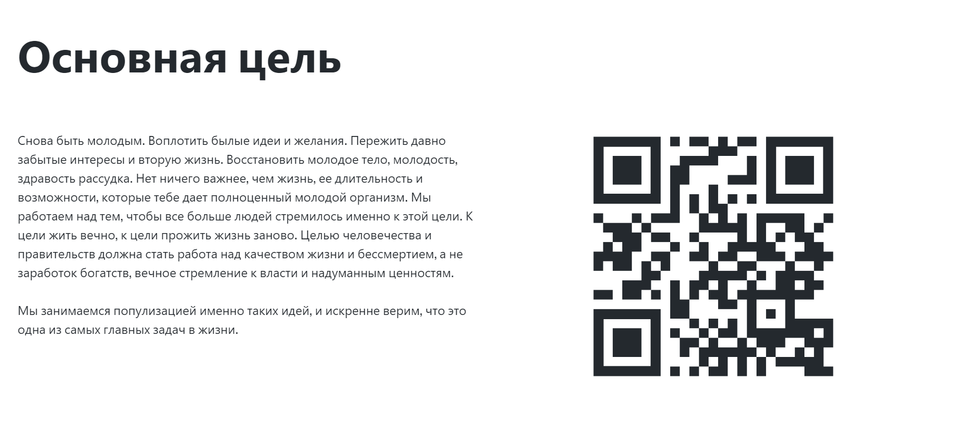

1. 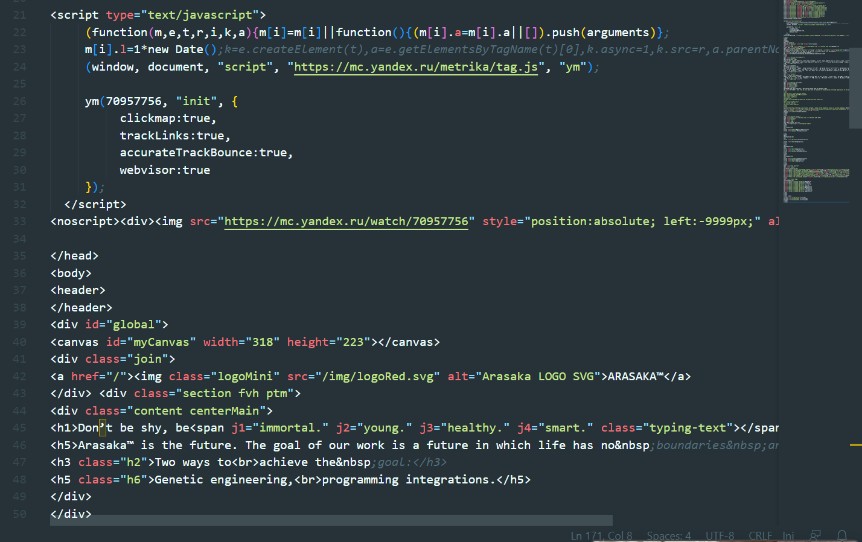**Arasaka Corporation Website QR Code in Russian**
2. **Arasaka Corporation Website HTML #1**

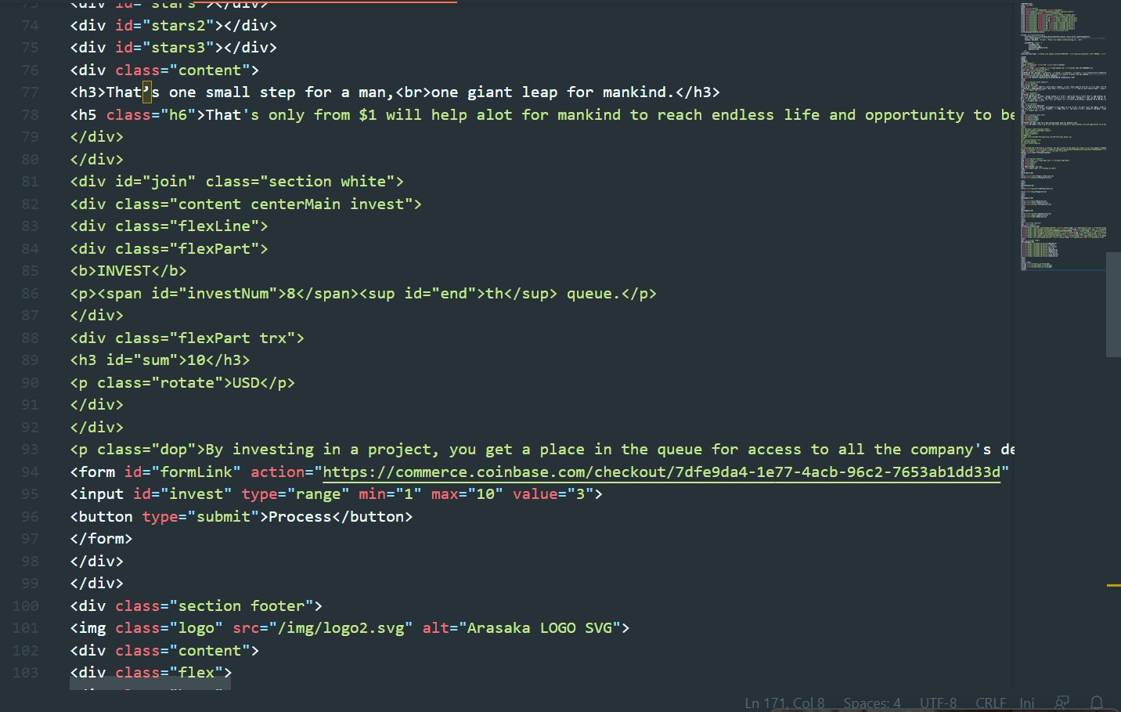

1. 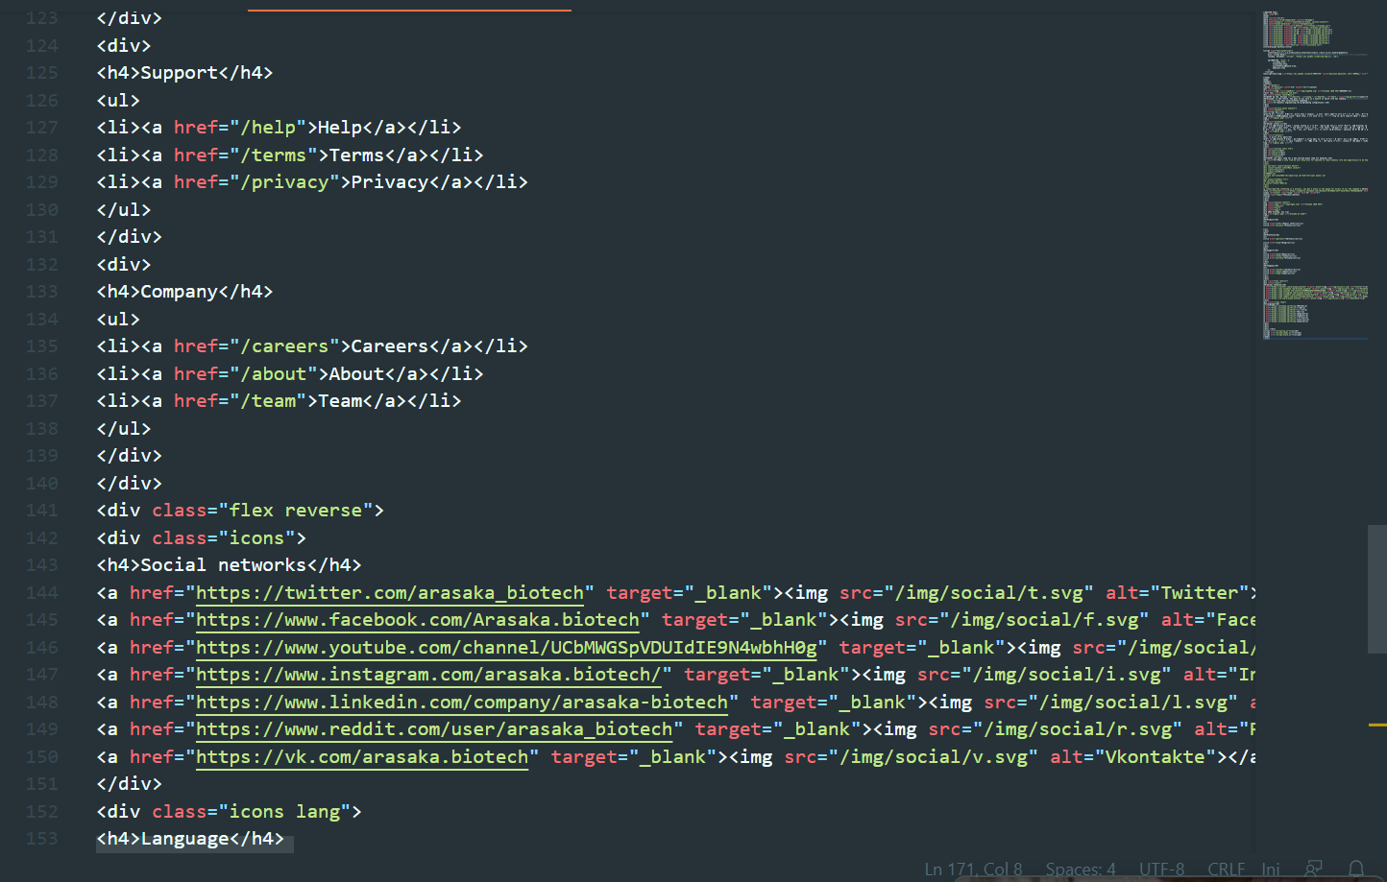**Arasaka Corporation Website HTML #2-3**

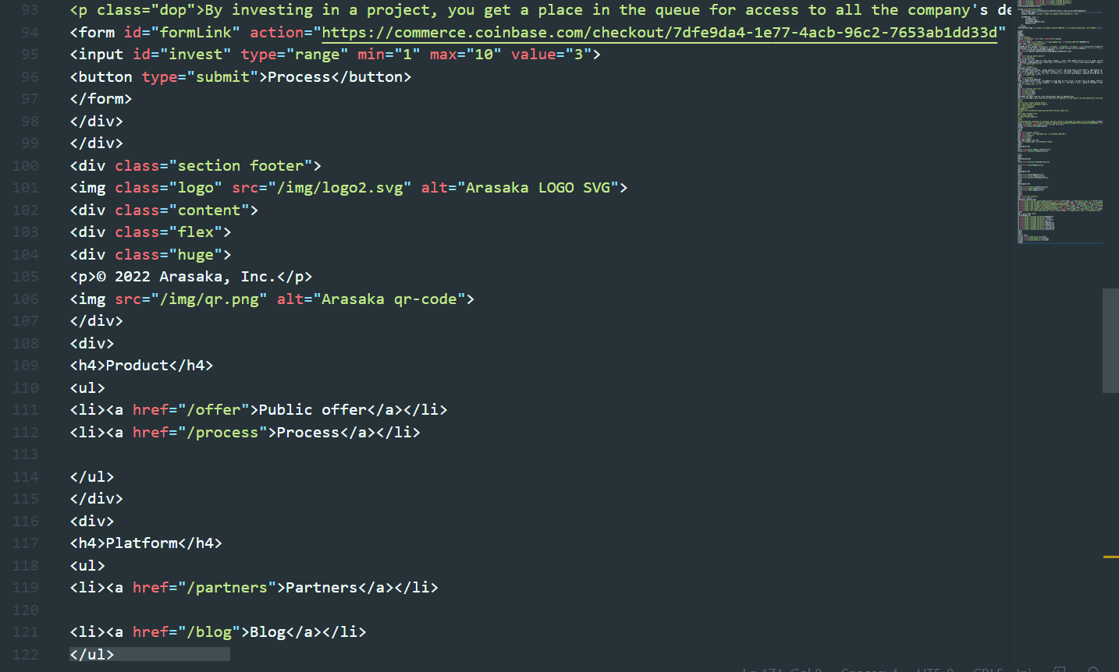

1. 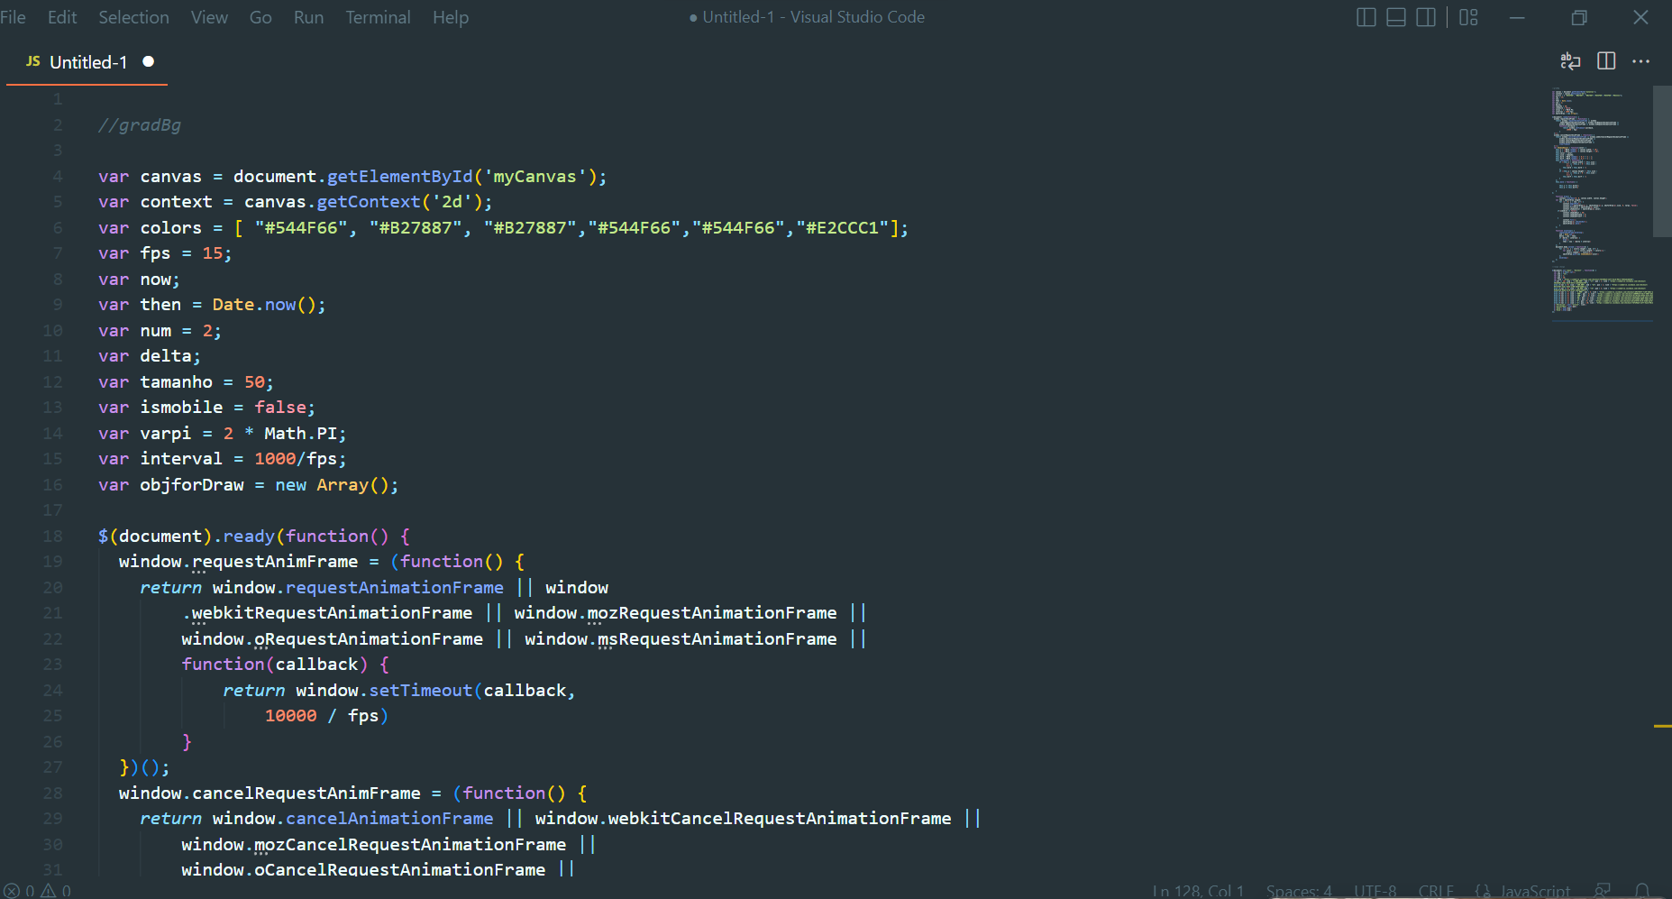**Arasaka Corporation Website HTML #4**
2. **Arasaka Corporation Website Javascript #1**

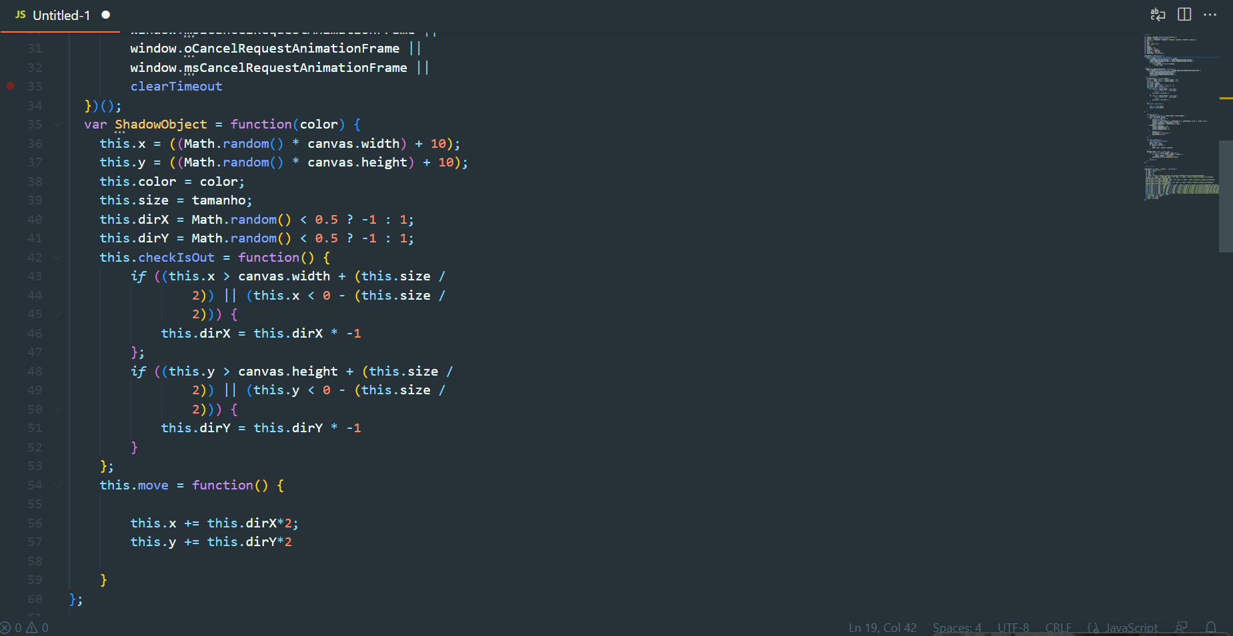

1. **Arasaka Corporation Website Javascript #2-3**

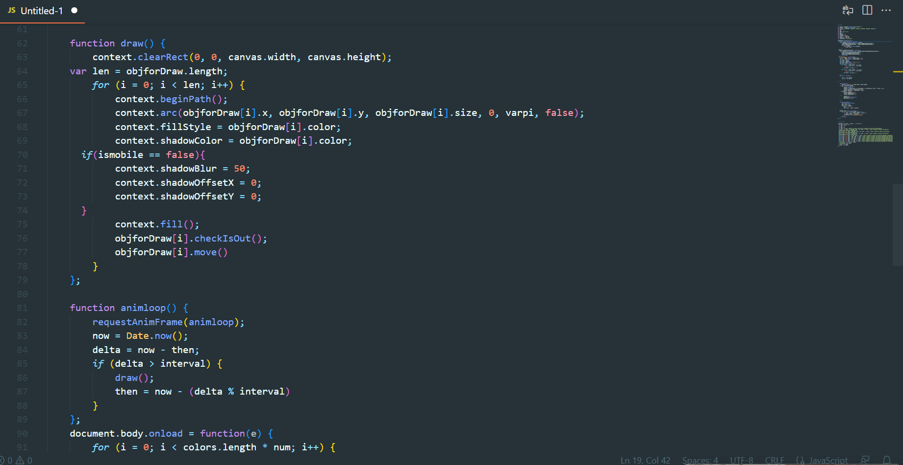

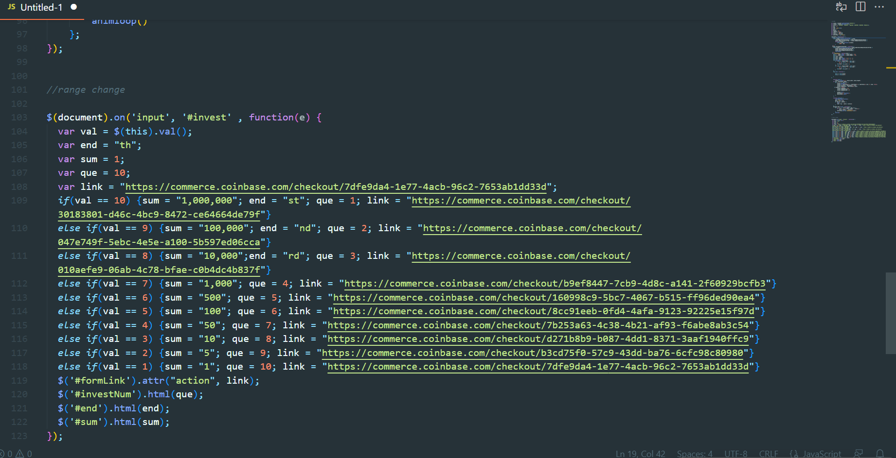

1. 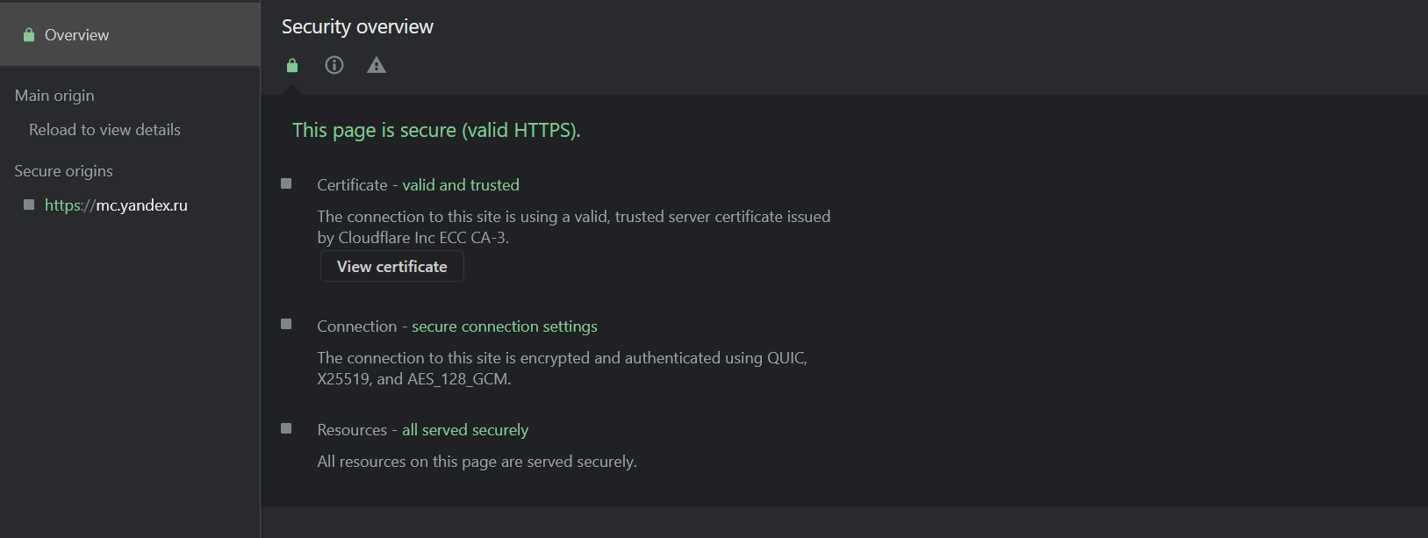 **Arasaka Corporation Website Javascript #4**
2. **Arasaka Corporation Website Security Overview**

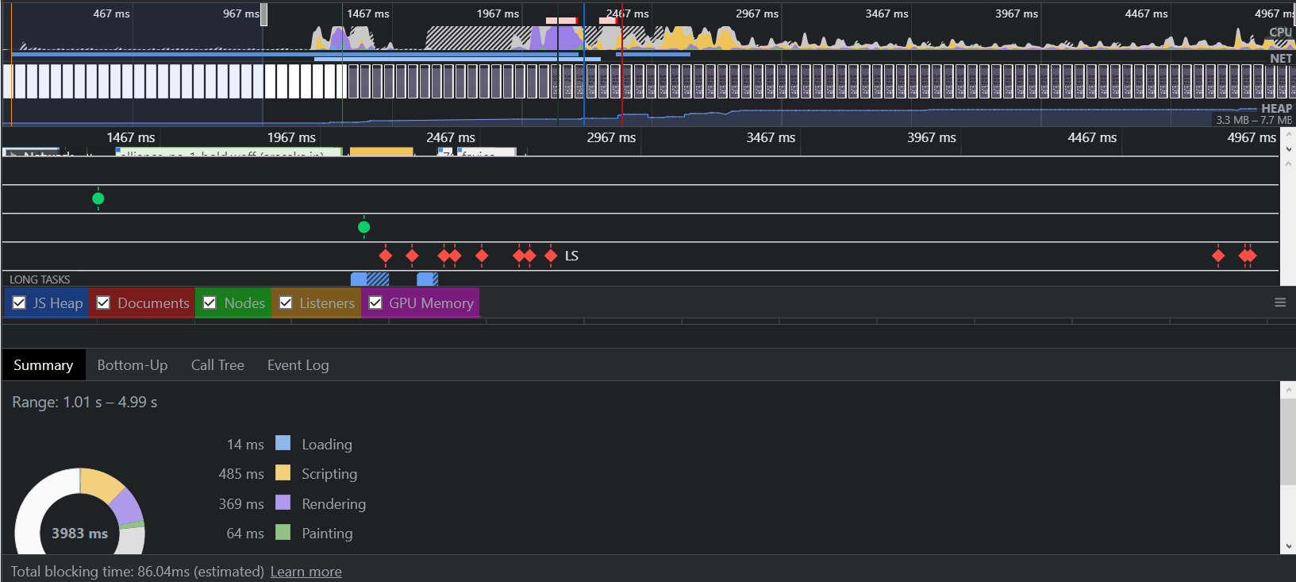

1. **Arasaka Corporation Website Tree Map**

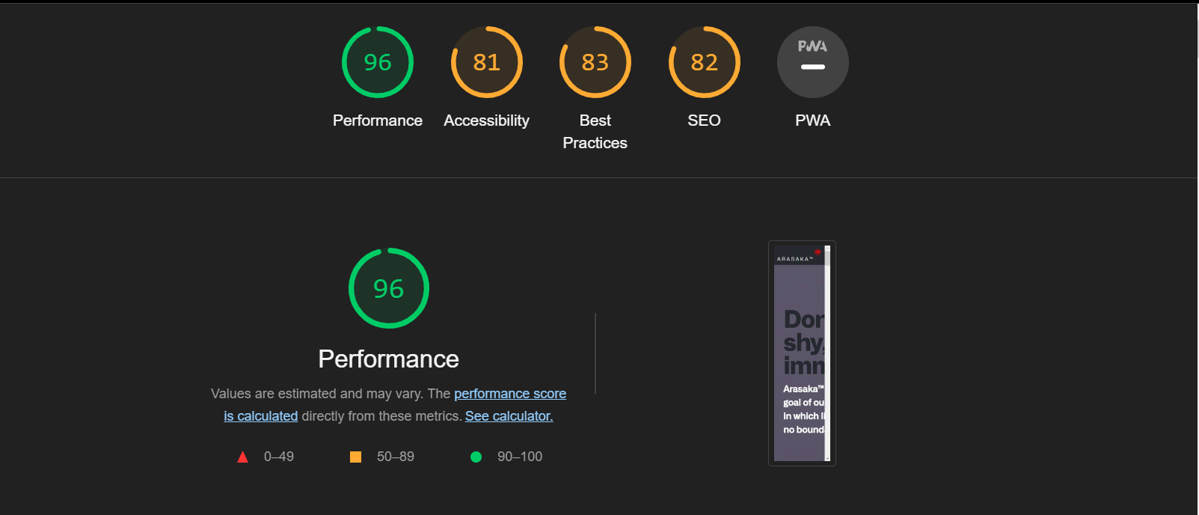

1. **Arasaka Corporation Website Lighthouse Performance**

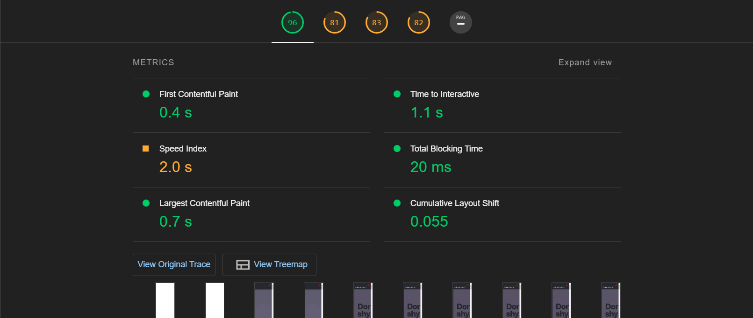

1. **Arasaka Corporation Website Lighthouse Metrics and Oppurtunities #2-3**

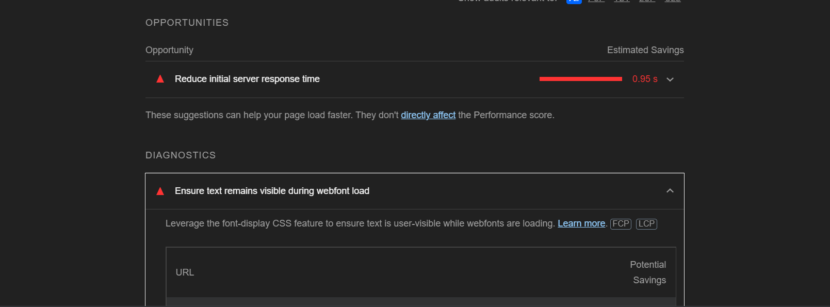

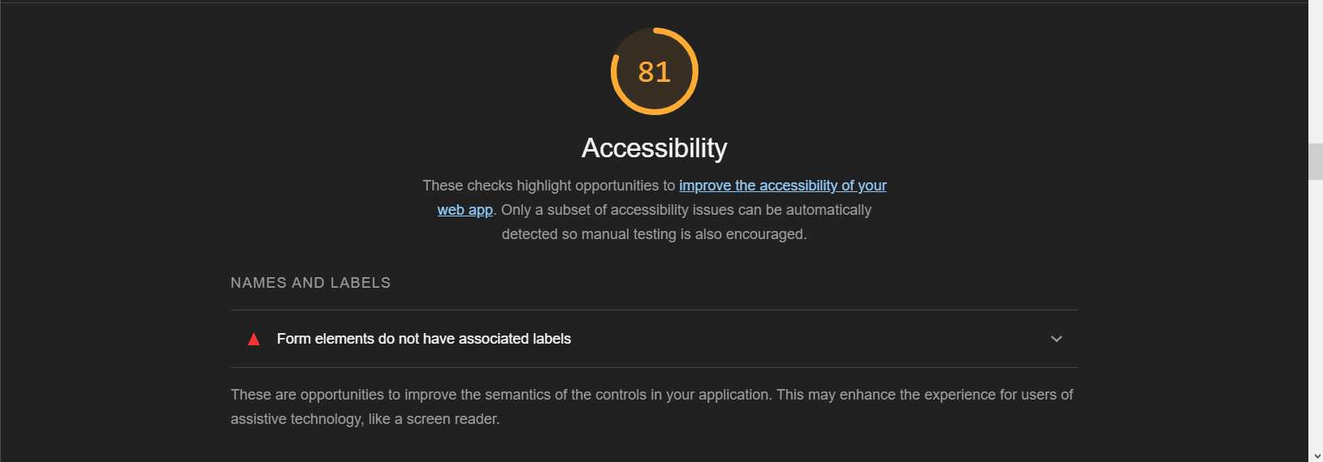

1. 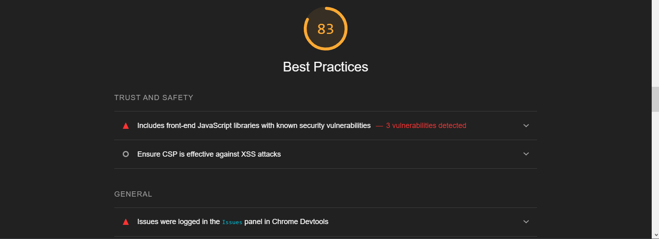**Arasaka Corporation Website Lighthouse Accessibility #4**
2. **Arasaka Corporation Website Lighthouse Best Practices #5**

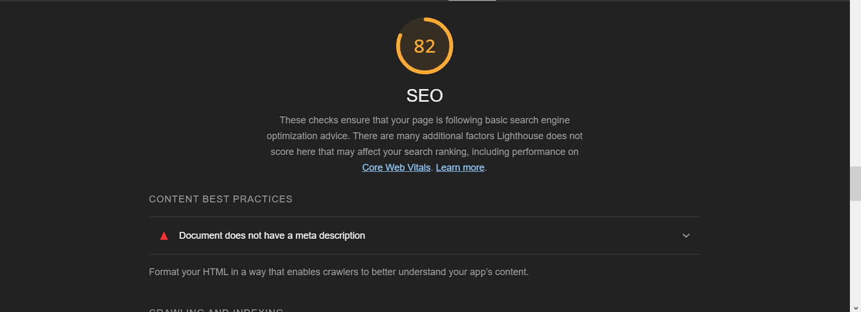

1. **Arasaka Corporation Website SEO Lighthouse #6**

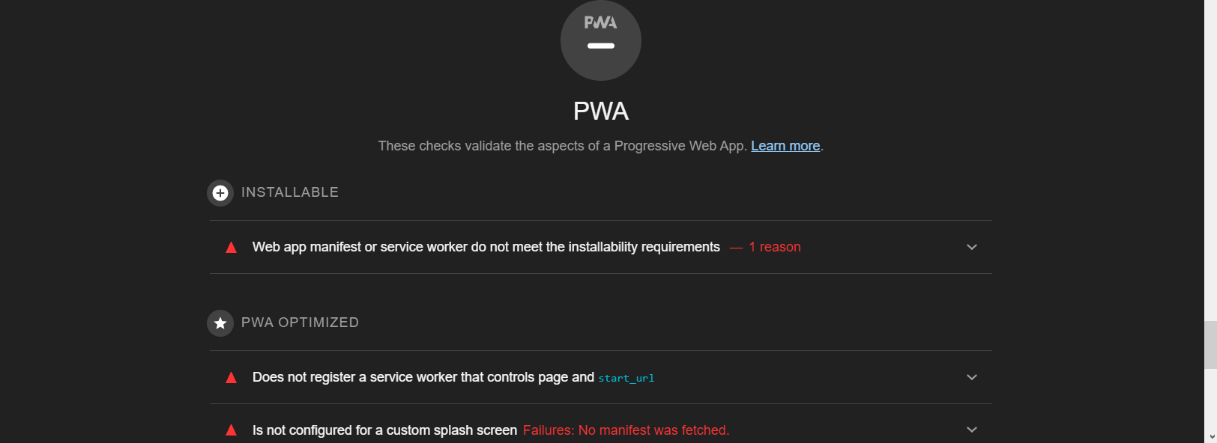

1. **Arasaka Corporation Website PWA Lighthouse #7**

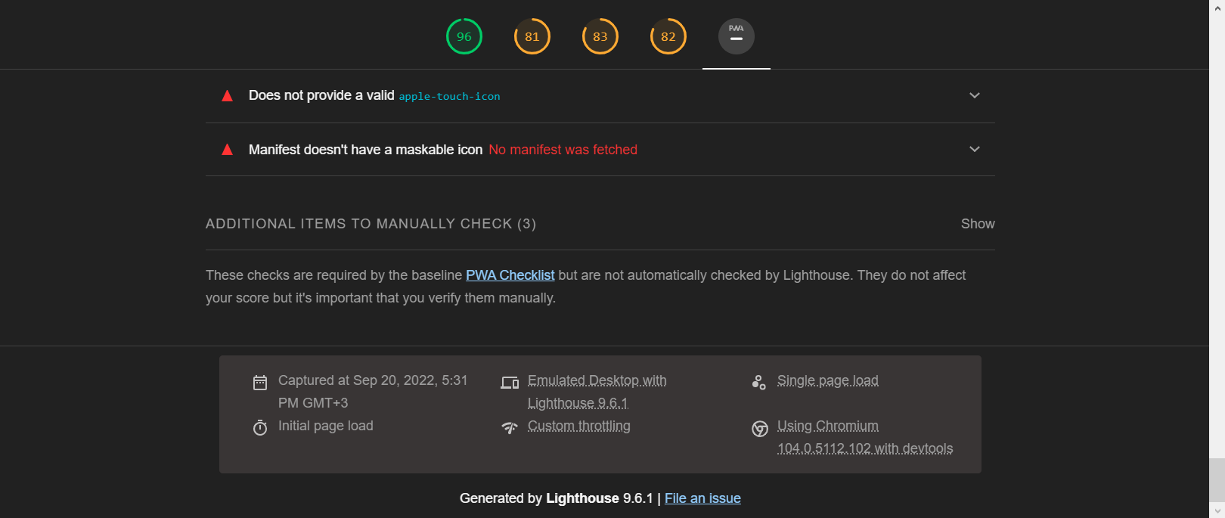

1. 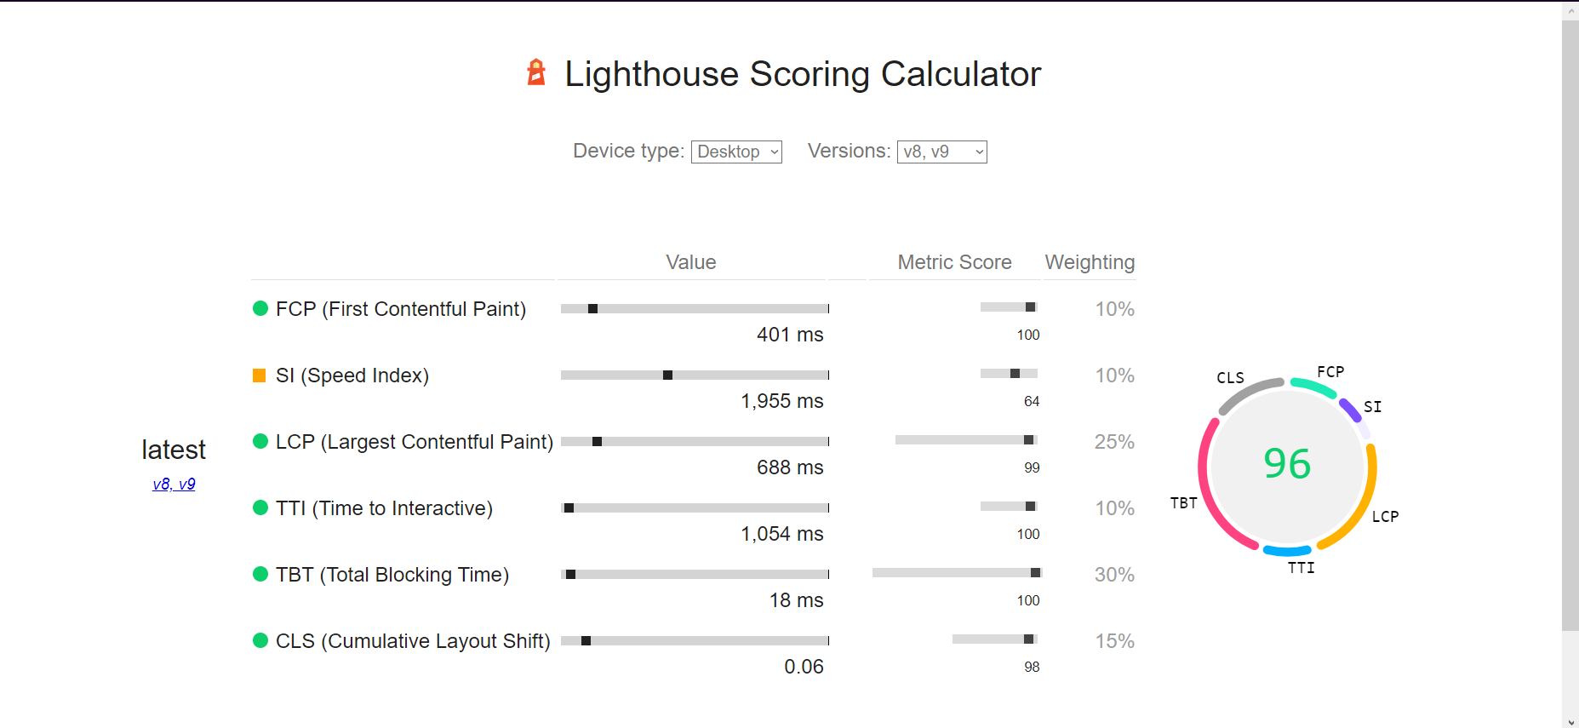**Arasaka Corporation Website Lighthouse #8**
2. **Arasaka Corporation Website Lightouse Scoring Calculator**

**References:**

**Bibliography**

<https://cyberpunk.fandom.com/wiki/Arasaka#Main_Intent_&_Services>

<https://www.linkedin.com/company/arasaka-corporation/mycompany/>

<https://cyberpunk.fandom.com/wiki/Arasaka>

<https://cyberpunk.fandom.com/wiki/Relic>

<https://cyberpunk.fandom.com/wiki/Diary_(117-121/77)>

<https://web.dev/performance-scoring/?utm_source=lighthouse&utm_medium=devtools>

<https://web.dev/performance-scoring/>

<https://cyberpunk.fandom.com/wiki/The_Relic_-_why_all_the_fuss%3F>